DOCUMENT 30 — Monetization & Billing Implementation
Visionary Internal · v1.0 · Entitlements server-side; lapse never deletes learning

Billing must reconcile to the rupee (Doc 18 KF5) and never interrupt a child mid-lesson
(Doc 23 KF4). Money logic lives in billing-service; UI only renders entitlements.

1. Plans & entitlements (locked, Doc 06)

Plan | Price | Key entitlements
Free | ₹0 | daily Ask turns, Learn/Practice core, portfolio view (share locked)
Student | ₹199/mo | unlimited Ask, 3D library, portfolio share, mocks
Competitive | ₹499/mo | + full mock suite, rank predictor, weak-chapter heatmap
Professional | ₹399/mo | skill tracks, certificates, portfolio export
Family | ₹599/mo | 4 learner seats + parent dashboards
Parent add-on | ₹99/mo | parent dashboards on a Free/Student child
School/coaching | ₹5,00,000/yr (or per-seat ₹50–200/student/mo for smaller institutes) | cohorts, teacher tools, analytics
Corporate/B2G/API | custom | org governance, whitelabel, SLA
Marketplace: creator receives 70–75%; platform commission 25–30%.

2. Billing flow
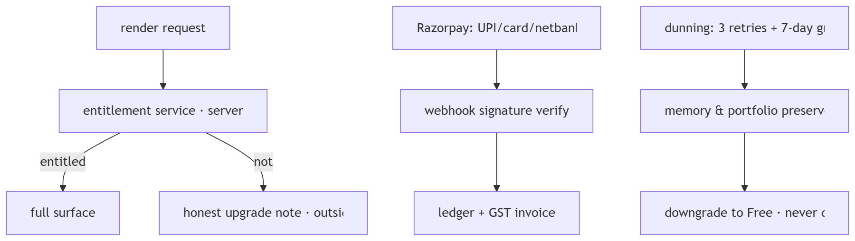

3. Rules
- No paywall inside child teaching; upgrade notes only at natural boundaries (portfolio
share, mock suite), worded honestly, no invented scarcity.
- Lapse preserves SCM/memory/portfolio forever; re-subscribe resumes exactly.
- Refunds: 7-day no-questions on first subscription; school PO/invoice flow separate.
- Family/org seats managed by owner; seat changes pro-rated; owner cancellation never
silently removes a member's personal memory (consent-scoped export offered).

OKF
KF1 entitlement check on 100% of gated renders, server-side · KF2 ledger reconciles to
payment provider to the rupee daily · KF3 lapse → downgrade with zero data loss ·
KF4 zero paywall events inside child teaching sessions · KF5 GST invoices auto-issued
on every charge.

